PROJECT PROPOSAL:

**CS-121**

**(OBJECT ORIENTED PROGRAMMING)**

Project Title: ‘**Typing Master’**

Course Instructor:  **Fatima Shakeel**

Signature:

**GROUP MEMBERS:**

Name: **Muhammad Asfiyan**  Roll No: **21B-111-SE**

Name: **Muhammad Amir** Roll No: **21B-211-SE**

Name: **Hafiza Malaika** Roll No: **21B-220-SE**

Name: **Rubaisha Khursid** Roll No: **21B-197-SE**

**PROJECT DESCRIPTION:**

We have implemented the python typing speed test successfully. GUI application development in python is fun. Tkinter provides most of the functionalities as pre-built. We hope now you have a clear understanding of gui(), complete() functions, and Tkinter.

**CODE:**

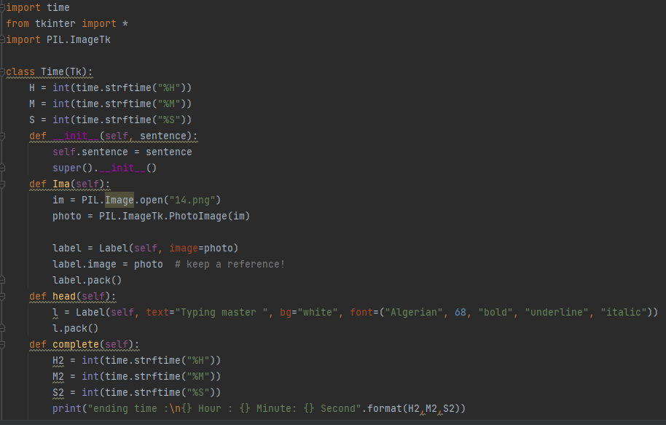

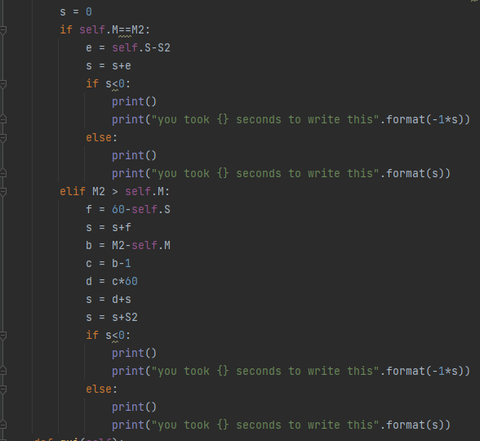

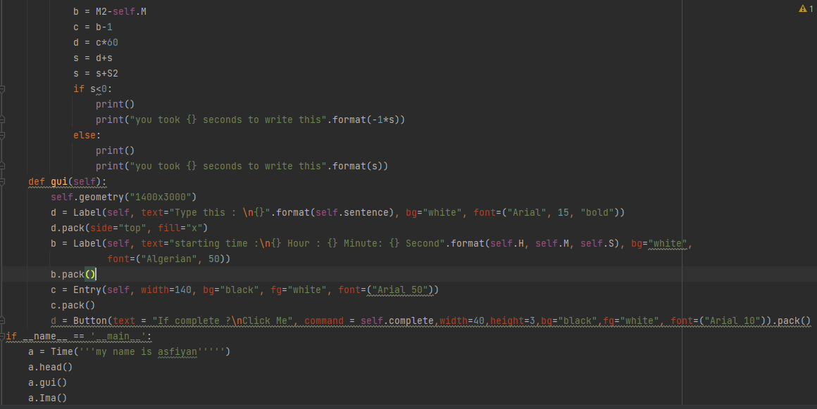

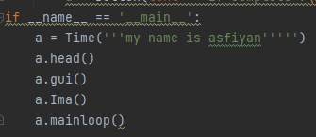

**Output:**

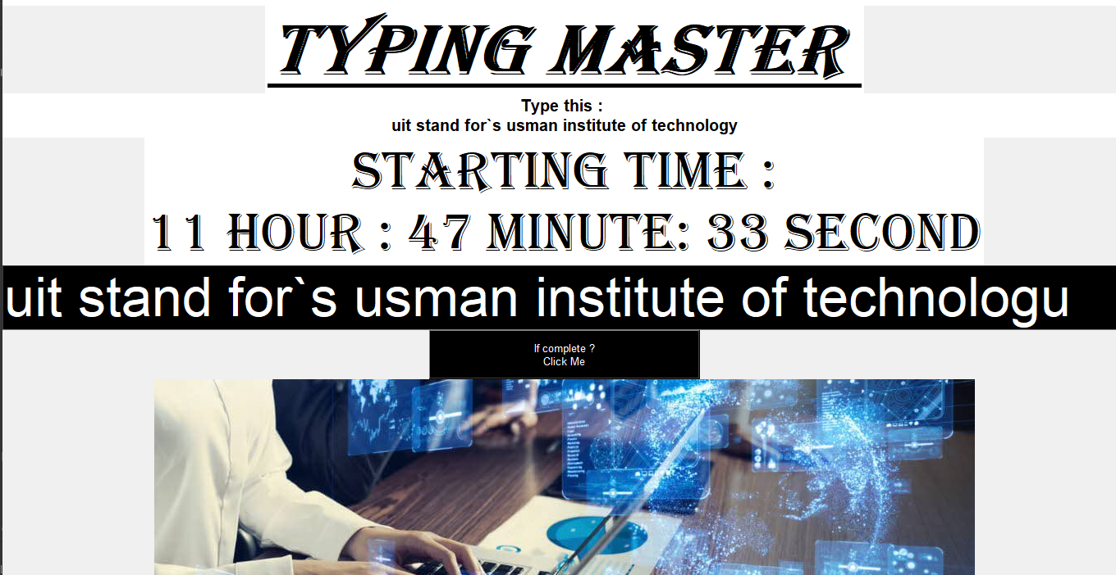

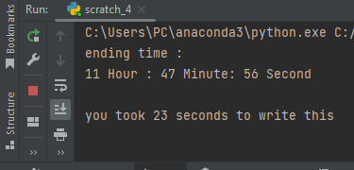

**Uml diagram:**

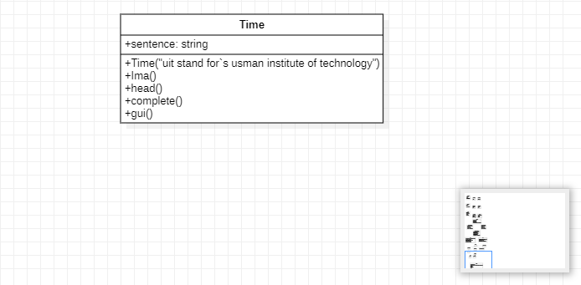

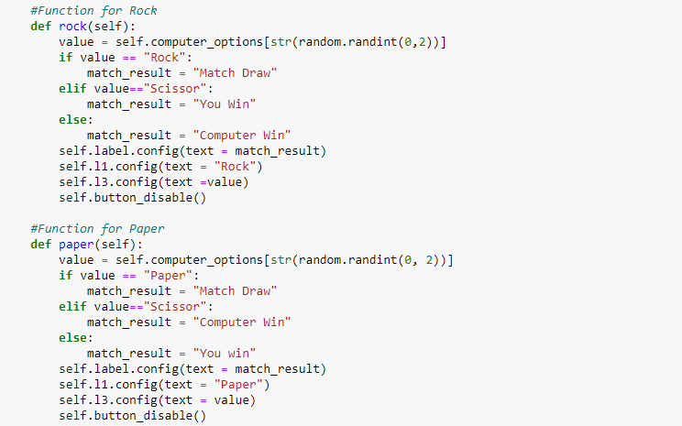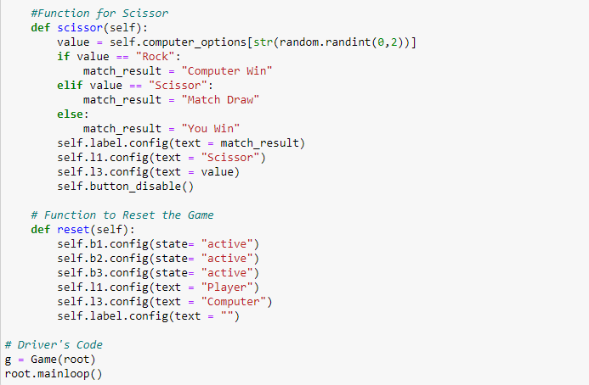

**OUTPUT WINDOW:**

